GGB Lab: The Burning Tent Problem
(revised for Geogebra from Exploring Geometry with The Geometer’s Sketchpad Key Curriculum Press, 2012, pp 65)

OBJECTIVE: In this investigation you will determine the shortest two-part path to help a camper put out a fire based on the problem scenario described.

SKECTH and INVESTIGATE: Open a new GGB file and save it as “Lab The Burning Tent”
Answer the questions in your composition book as you complete the lab and questions are asked.

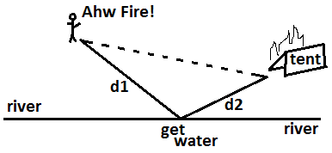
A camper out for a hike is returning to her campsite. The shortest distance between her and her campsite is along a straight line, but as she approaches her campsite, she sees that her tent is on fire! She must run to the river to fill her canteen, and then run to her tent to put out the fire. What is the shortest path she can take? In this exploration you will investigate the minimal two-part path that goes from a point to a line and then to another point.

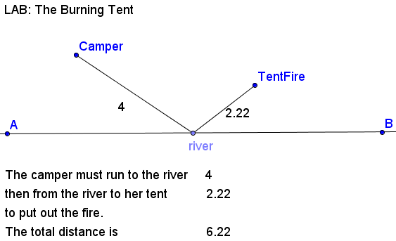
- Create a text box with the text: “LAB: The Burning Tent”
- Construct a line AB representing the river.
- Construct point C and D on the same side of the line. Change the name of C to Camper. Change the name of D to TentFire.
- Construct point E on line AB to represent the location where the camper will get water. Change the name of E to river.
- Construct segment from the points Camper to River and a second segment from the points River to TentFire.
- Measure the lengths of these distances.
- Drag point River along line AB and notice how the values of the distances changes.
- In the INPUT bar at the bottom of the screen, type: TotalDistance = b + c (Be sure to use the names of the segment lengths listed in the “segment” section of the algebra window.)
- Create a text box as shown in the picture above to show the distance the camper must walk to the river and from the river to her tent.
- Locate the point on the line AB where the total distance appears to be the smallest.
- Measure the incoming angle of the camper’s path with the river. This angle is Camper-River-A so when you use the Angle measuring tool select these points in this order..
- Measure the outgoing angle of the camper’s path with the river. This angle is B-River-TentFire so when you use the Angle measuring tool select these points in this order.
- Change the rounding to 5 decimals: OPTIONS, Rounding, 5 decimals.
- Drag the point River until you find the minimal path. Can you make the minimal path any smaller?
QUESTION 1: Once you have the minimal path, what appears to be true about the incoming angle and the outgoing angle?
- So far you have dragged the point River to find an approximate minimal path. Next you will discover how to construct such a path.
- Reflect the point TentFire in the line AB that represents the river to create point TentFire’
- Construct the segment from Camper to TentFire’. Change the style of this segment to dashed.
QUESTION 2: Why is the segment from Camper to TentFire’ the shortest path? Briefly explain.
QUESTION 3: Where should point River be located in relation to the segment Camper to TentFire’ and line AB so that the sum of the distances is minimized? Drag point River to test your conjecture.

